**Methodology:**

The Assignment is based on “**Superstore_Canada.xls**” Dataset. In this Dataset we have information about Sales with their Customers, Products, sales details information.

**Dashboard / Output**

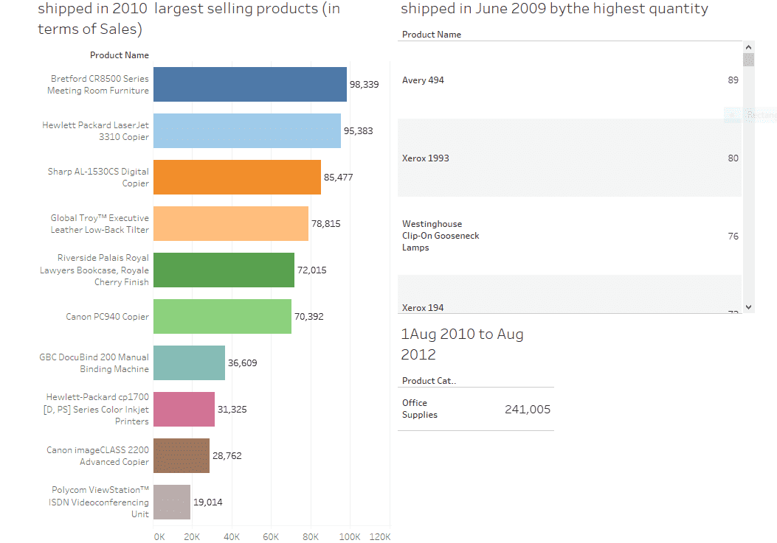

**Date Filters answers**

**Out of all the products shipped in year 2010 which was the largest selling products (in terms of Sales) ?**

Ans –Bretford CR8500 Series Meeting Room Furniture

**Of all the products shipped in June 2009 which had the highest quantity?**

Ans –Avery494

**As per the order date what was the total profit generated by Product Category = “ Office Supplies “ between 1stAug 2010 to Aug 2012 ?**

Ans –241, 005